V5 LOGISTICS AND WAREHOUSING
Transportation Cost Optimization & Financial Impact Assessment
Bhiwandi vs. Proposed Kolhapur Mini-Hub: a modelled scenario analysis
Modelled gross savings, not verified company results
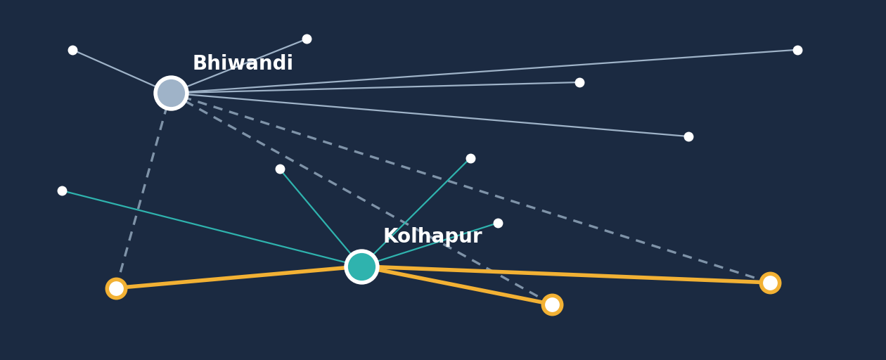

Prepared by: Mahir Valani, Intern, V5 Logistics and Warehousing
Companion to: Transportation Network & Transit-Time Optimization report (same network context and hub allocation)
This report is a scenario analysis using supplied assumptions. It is not an independently verified record of company expenditure. Cost analysis and freight quotations were handled by senior management and the head-office team. Illustration is schematic and not to scale.

Contents
1 Executive Summary and Dashboard
2 Context, Scope and Modelling Rules
3 Base Model Assumptions
4 Route-Level Cost Models
5 Consolidated Financial Analysis
6 Cost Component Analysis
7 Incremental Hub Costs and Break-Even
8 Transportation Cost and Network Design
9 Financial Risk Register
10 Management Dashboard and KPIs
11 Implementation Roadmap
12 Data Limitations
13 Final Recommendation
Appendix A Financial Assumptions
Appendix B Formulas and Audit Trail
Appendix C Data Notes and Reconciliation

Evidence labels used in this report
• Source input: supplied rate, distance, cost or quantity.
• Calculation: derived arithmetically from source inputs.
• Assumption: scenario value chosen for modelling (80 machines per route; illustrative hub costs; 5–6% hypothesis).
• Recommendation: analyst judgement requiring validation.
All savings are modelled gross transportation-cost savings, not verified realised savings. Amounts use Indian number formatting (₹5,36,000).

1 Executive Summary
Management decision
The supplied model indicates modelled gross transportation-cost savings of ₹2,60,560 (14.78%) across three illustrative route comparisons, but this is not yet a business case. Incremental Kolhapur hub costs are unknown, and the Chennai cost inputs are unconfirmed. Proceed to commercial validation and hub-cost measurement, then a controlled pilot, before treating any saving as real.

The model compares the cost of moving 80 machines on each of three source routes (Goa, Bengaluru, Chennai) through Bhiwandi versus a proposed Kolhapur mini-hub. Each route covers primary transportation (per vehicle of 20 machines), secondary transportation and last-mile delivery (per machine). Primary cost is lower via Kolhapur on every route, secondary cost is ₹500 lower per machine, and last-mile cost is unchanged.

Dashboard
₹17,62,400  Baseline cost (Bhiwandi)  240 machines, 12 loads (modelled) | ₹15,01,840  Proposed cost (Kolhapur)  Same quantity, same basis | ₹2,60,560  Modelled gross saving  Before incremental hub costs
14.78%  Gross cost reduction  ₹2,60,560 ÷ ₹17,62,400 | ₹1,086  Average saving per machine  ₹2,60,560 ÷ 240 (rounded) | ₹2,60,560  Break-even hub cost  Hub costs above this erase the gross saving

Source route | Baseline (80 machines) | Proposed (80 machines) | Modelled gross saving | Reduction | Saving per machine
Goa | ₹5,36,000 | ₹4,44,000 | ₹92,000 | 17.16% | ₹1,150
Bengaluru | ₹5,92,000 | ₹5,05,840 | ₹86,160 | 14.55% | ₹1,077
Chennai (inputs unconfirmed) | ₹6,34,400 | ₹5,52,000 | ₹82,400 | 12.99% | ₹1,030
Total (3 routes) | ₹17,62,400 | ₹15,01,840 | ₹2,60,560 | 14.78% | ₹1,086 (avg)
Source: supplied model assumptions; analyst calculations. 240 machines and 12 loads are sums of the modelling basis, not actual shipment volumes.
Audit note
All rupee figures in the brief reconcile exactly. One rounding correction: the combined reduction is 2,60,560 ÷ 17,62,400 = 14.784%, which rounds to 14.78%, not 14.79%. This report uses 14.78% (Appendix C).
What this does not show. The result is not a verified company saving. It excludes incremental Kolhapur hub costs, depends on supplied rates and an assumed volume, assumes every machine goes to the Kolhapur catchment, and relies on Chennai inputs that need confirmation.

Figure 1. Total modelled cost by route, Bhiwandi vs Kolhapur scenario
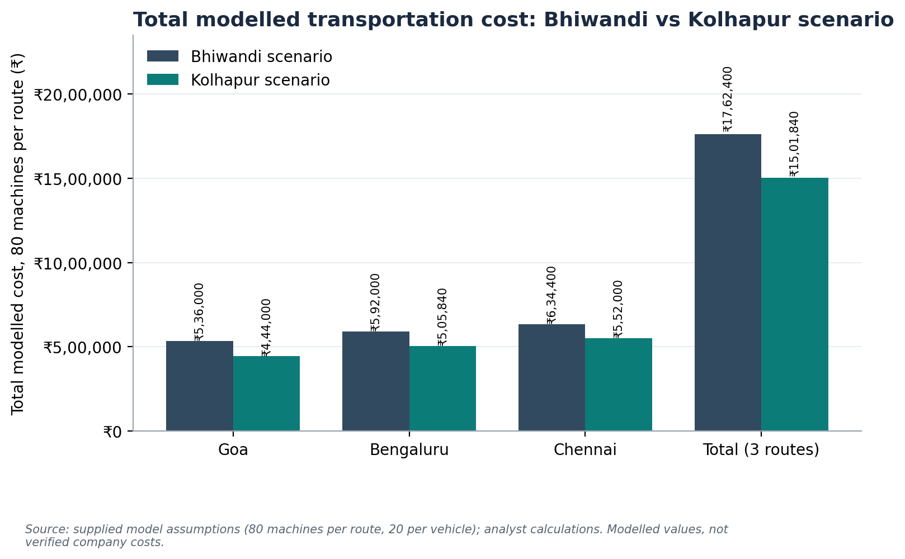
Source: supplied assumptions; analyst calculations.
Figure 2. Modelled gross saving by source route
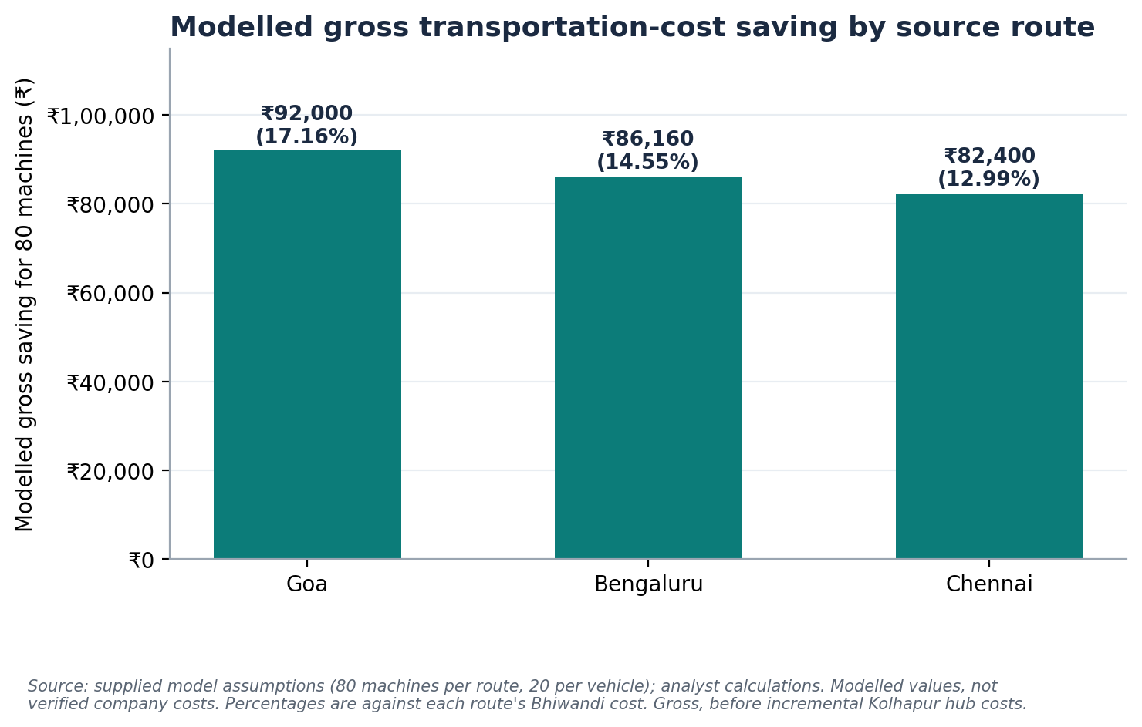
Gross, before incremental hub costs. Percentages are against each route's Bhiwandi cost.

2 Context, Scope and Modelling Rules
V5 Logistics and Warehousing operates a Maharashtra network from an existing hub at Bhiwandi. The accompanying transit-time report screened where a proposed Kolhapur mini-hub appears to shorten estimated driving time. This report asks a different question: what is the illustrative transportation cost of routing selected movements through each hub?
Cost analysis and freight quotations were handled by senior management and the head-office team. The model here uses the supplied assumptions and is not an independently verified record of company expenditure.

Modelling rules applied
- Source inputs, calculations, assumptions and recommendations are labelled separately.
- No trip frequencies, fuel costs, salaries, rent, electricity or actual shipment volumes are invented.
- Route-specific cost distances are used as supplied, even where they differ from the transit-time report.
- The same 80-machine basis applies to both scenarios on each route.
- Every number can be audited from the workbook formulas.
- Savings are labelled modelled gross transportation-cost savings; incremental Kolhapur costs are kept separate.
- Net benefit is not called a profit margin: no revenue data exist.
- Uncertain inputs (notably Chennai) are flagged, not silently replaced.

3 Base Model Assumptions
Assumption | Value | Type
Vehicle type | 6-tyre vehicle | Source input
Nominal vehicle capacity | 10 tonnes | Source input
Maximum planning capacity | 20 machines per vehicle | Source input
Modelled quantity per route | 80 machines (4 loads of 20) | Assumption – not actual volume
Primary transportation cost basis | Per vehicle | Source input
Secondary and last-mile cost basis | Per machine | Source input
Quantity in both scenarios | Identical on each route | Modelling rule
The 80-machine quantity is the supplied modelling basis. It must not be read as actual company shipment volume unless verified by company records.

4 Route-Level Cost Models
Primary cost per machine = primary cost per vehicle ÷ 20. Total cost per machine = primary + secondary + last-mile. Cost for 80 machines = total per machine × 80.

Goa
Line | Bhiwandi scenario | Kolhapur scenario | Difference
Primary distance × rate | 600 km × ₹40/km | 250 km × ₹44/km | 350 km shorter
Primary cost per vehicle | ₹24,000 | ₹11,000 | ₹13,000
Primary cost per machine | ₹1,200 | ₹550 | ₹650
Secondary per machine | ₹3,000 | ₹2,500 | ₹500
Last-mile per machine | ₹2,500 | ₹2,500 | ₹0
Total per machine | ₹6,700 | ₹5,550 | ₹1,150
Cost for 80 machines | ₹5,36,000 | ₹4,44,000 | ₹92,000 (17.16%)
Saving per 20-machine load |  |  | ₹23,000
Source inputs: distances, rates, secondary and last-mile costs. Calculations: all other lines. Kolhapur rate is higher per km (₹44 vs ₹40) but the shorter distance more than offsets it.

Bengaluru
Line | Bhiwandi scenario | Kolhapur scenario | Difference
Primary distance × rate | 1,000 km × ₹38/km | 630 km × ₹42/km | 370 km shorter
Primary cost per vehicle | ₹38,000 | ₹26,460 | ₹11,540
Primary cost per machine | ₹1,900 | ₹1,323 | ₹577
Secondary per machine | ₹3,000 | ₹2,500 | ₹500
Last-mile per machine | ₹2,500 | ₹2,500 | ₹0
Total per machine | ₹7,400 | ₹6,323 | ₹1,077
Cost for 80 machines | ₹5,92,000 | ₹5,05,840 | ₹86,160 (14.55%)
Saving per 20-machine load |  |  | ₹21,540
Source inputs: distances, rates, secondary and last-mile costs. Calculations: all other lines.

Chennai (supplied working figures, pending confirmation)
Line | Bhiwandi scenario | Kolhapur scenario | Difference
Primary cost per vehicle | ₹48,600 | ₹38,000 | ₹10,600
Primary cost per machine | ₹2,430 | ₹1,900 | ₹530
Secondary per machine | ₹3,000 | ₹2,500 | ₹500
Last-mile per machine | ₹2,500 | ₹2,500 | ₹0
Total per machine | ₹7,930 | ₹6,900 | ₹1,030
Cost for 80 machines | ₹6,34,400 | ₹5,52,000 | ₹82,400 (12.99%)
Saving per 20-machine load |  |  | ₹20,600
The underlying distance and rate calculation for Chennai is unconfirmed, so no per-km rate is shown or derived. The Kolhapur cost of ₹38,000 equals the Bengaluru Bhiwandi vehicle cost; verify against the original quotation that this is not a transcription slip.
Cost distances differ from the transit-time report
Cost distances are used as supplied: Goa–Kolhapur 250 km here against 223 km in the transit-time report (where digits were unclear), and Bengaluru 1,000 km and 630 km against 1,002 km and 631 km. The differences are preserved, not reconciled.

5 Consolidated Financial Analysis
Route | Bhiwandi cost | Kolhapur cost | Modelled gross saving | Reduction
Goa | ₹5,36,000 | ₹4,44,000 | ₹92,000 | 17.16%
Bengaluru | ₹5,92,000 | ₹5,05,840 | ₹86,160 | 14.55%
Chennai | ₹6,34,400 | ₹5,52,000 | ₹82,400 | 12.99%
Total | ₹17,62,400 | ₹15,01,840 | ₹2,60,560 | 14.78%
Combined reduction = ₹2,60,560 ÷ ₹17,62,400 × 100 = 14.784%, shown as 14.78%. Saving is across 240 machines and 12 assumed vehicle loads, which are modelling assumptions, not actual volumes.
The three routes are an illustrative comparison. The model does not imply that all three operate at this volume or frequency in actual business operations, and the total is not an annual or monthly saving.
Key modelling assumption to confirm
Each route's 80 machines are costed entirely through the Kolhapur catchment. In the proposed allocation, destinations such as Pune, Nagpur and Nashik remain with Bhiwandi, so freight bound for them would not realise this saving. The real saving depends on the share of volume destined for the Kolhapur catchment.

6 Cost Component Analysis
Figure 3. Cost per machine by component and hub scenario
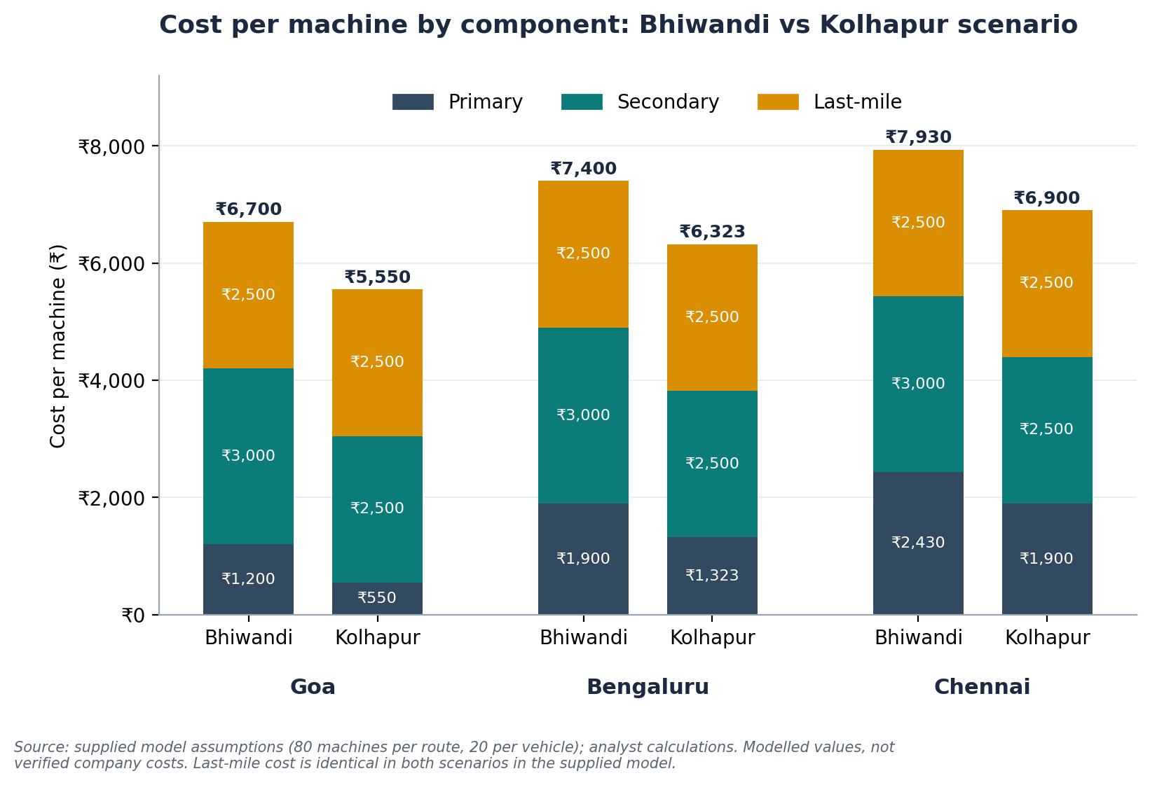
Source: supplied assumptions. Last-mile is identical in both scenarios.
Route | Primary saving / machine | Secondary saving / machine | Last-mile saving / machine | Total / machine | Primary share | Secondary share
Goa | ₹650 | ₹500 | ₹0 | ₹1,150 | 56.52% | 43.48%
Bengaluru | ₹577 | ₹500 | ₹0 | ₹1,077 | 53.57% | 46.43%
Chennai | ₹530 | ₹500 | ₹0 | ₹1,030 | 51.46% | 48.54%
Total (240 machines) | ₹1,40,560 | ₹1,20,000 | ₹0 | ₹2,60,560 | 53.95% | 46.05%
Totals row shows rupee savings for 240 machines. Shares are of total modelled saving.
Figure 4. Modelled gross saving by component and route
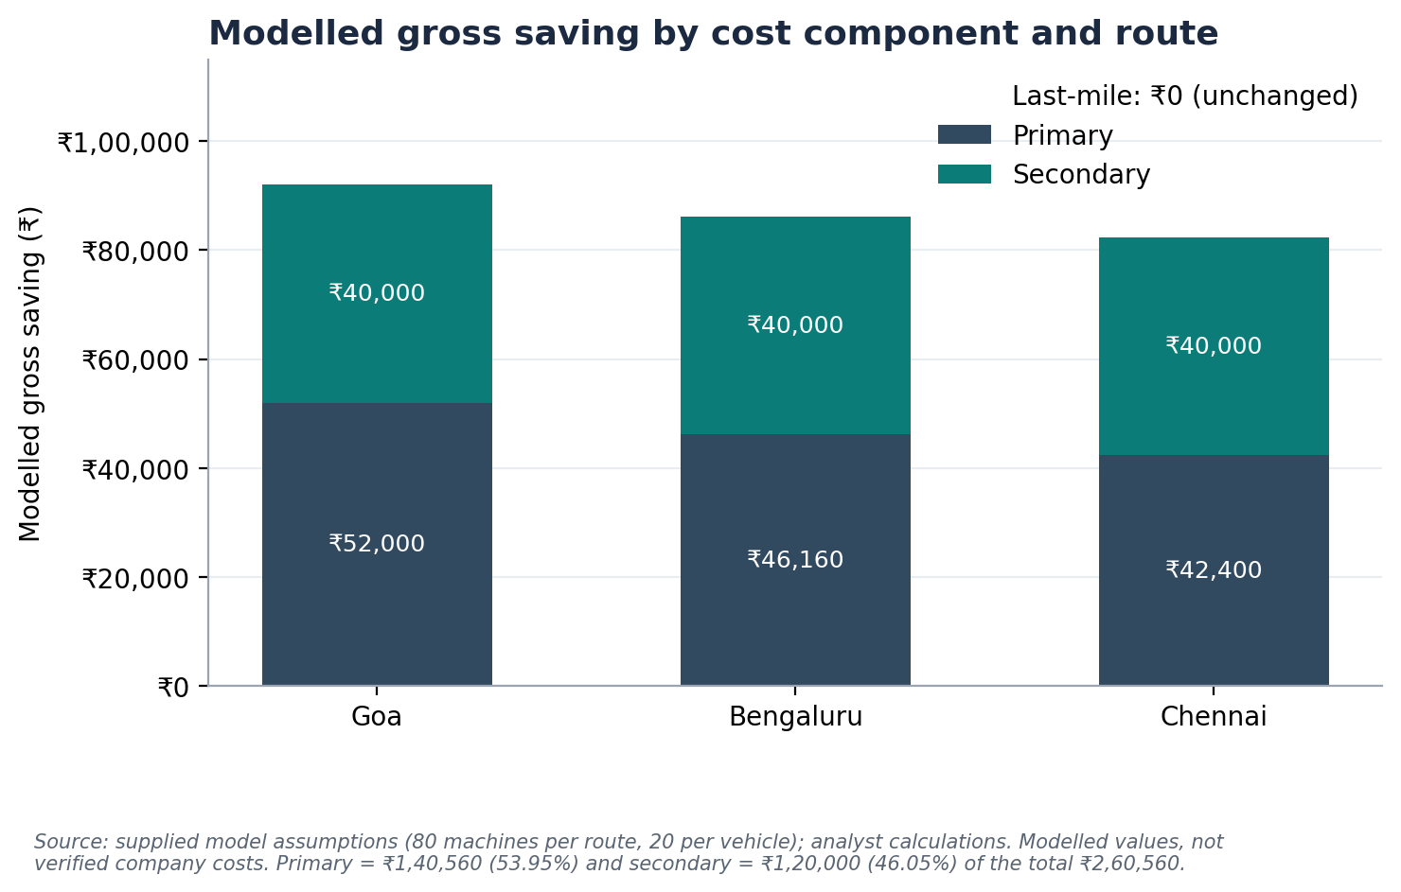
Source: supplied assumptions; analyst calculations.
Under the supplied assumptions, the modelled savings arise from three effects:
- Lower primary cost per machine via Kolhapur on every route: ₹1,40,560 in total, 53.95% of the saving.
- Lower secondary cost per machine: a flat ₹500, giving ₹1,20,000 in total, 46.05%.
- No change in last-mile cost: ₹2,500 in both scenarios, contributing ₹0.
Savings are not attributed to fuel efficiency, driver productivity, vehicle utilisation or procurement negotiations, because no supporting data were supplied.
Points to validate
• Uniform secondary saving. The ₹500 saving is identical on all routes, yet secondary distances differ by destination. Destination-level secondary rates should be confirmed.
• Primary rate headroom (calculated). Kolhapur's primary cost per vehicle would match Bhiwandi's only at about ₹96/km for Goa and ₹60.32/km for Bengaluru, against supplied rates of ₹44 and ₹42. The primary saving is therefore not very sensitive to modest rate changes, though this covers the primary component only.

7 Incremental Hub Costs and Break-Even
Opening a hub can add costs the transportation model does not capture: facility rent, utilities, additional labour, supervisory and administrative staff, material handling, loading and unloading, equipment and maintenance, security, local transportation, and additional transfer or handling movements. No actual values are available and none are invented.
Measure | Formula
Net modelled benefit | Gross transportation-cost saving − incremental hub operating costs
Net benefit percentage | Net modelled benefit ÷ baseline transportation cost × 100
Break-even incremental hub cost | Equals the gross transportation-cost saving (₹2,60,560)

Sensitivity to incremental hub cost
Incremental hub cost (illustrative) | Net modelled benefit | % of baseline (₹17,62,400) | Modelled outcome
₹0 | ₹2,60,560 | 14.78% | Positive
₹50,000 | ₹2,10,560 | 11.95% | Positive
₹1,00,000 | ₹1,60,560 | 9.11% | Positive
₹1,50,000 | ₹1,10,560 | 6.27% | Positive
₹2,00,000 | ₹60,560 | 3.44% | Positive
₹2,60,560 | ₹0 | 0.00% | Break-even
₹3,00,000 | −₹39,440 | −2.24% | Negative
Hub costs are illustrative inputs editable in the workbook, not V5 expense data. Net % is a percentage of baseline transportation cost, not a profit margin.
Figure 5. Net modelled benefit at illustrative incremental hub costs
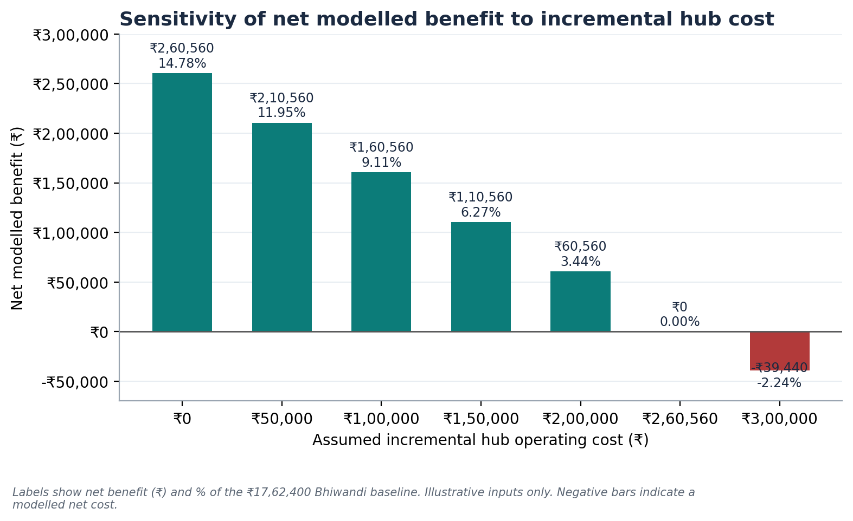
Figure 6. Break-even analysis and the 5–6% planning hypothesis
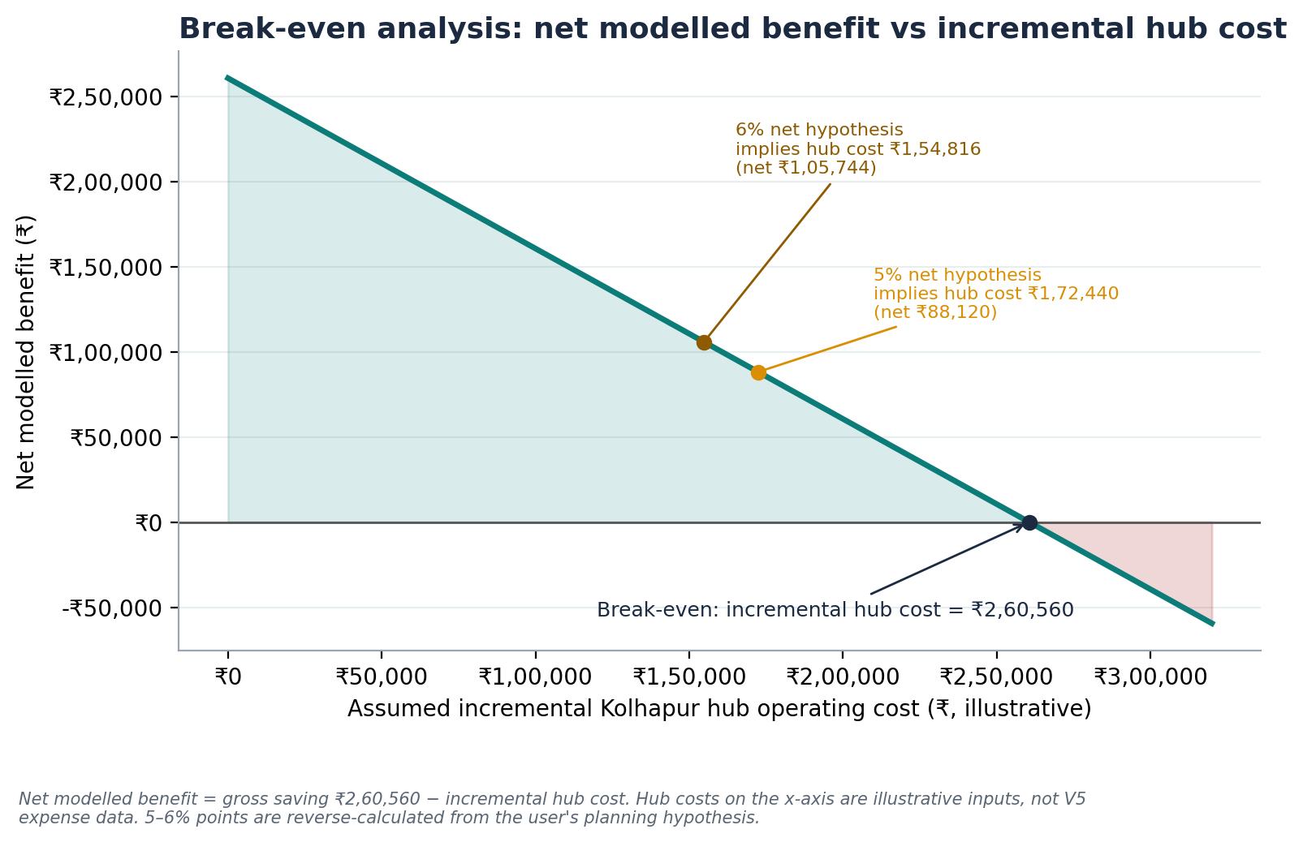

The 5–6% planning hypothesis (reverse calculation)
Management believes the final net cost benefit might be about 5–6% of the Bhiwandi baseline after incremental hub expenses. This is treated only as a scenario to test.
Scenario | Net benefit target | Net modelled benefit | Implied incremental hub expense
A | 5% of ₹17,62,400 | ₹88,120 | ₹2,60,560 − ₹88,120 = ₹1,72,440
B | 6% of ₹17,62,400 | ₹1,05,744 | ₹2,60,560 − ₹1,05,744 = ₹1,54,816
Reverse-calculated illustrations. They show what incremental hub costs would have to be for the net benefit to equal 5–6% of baseline; they do not establish V5's actual expenses or realised net savings.
In other words, a 5–6% net benefit is consistent with the model only if incremental hub costs come to roughly ₹1.55–1.72 lakh for the modelled 240 machines. Whether real costs fall there is unknown until measured.

8 Transportation Cost and Network Design
Figure 7. Selective hub allocation (working proposal)
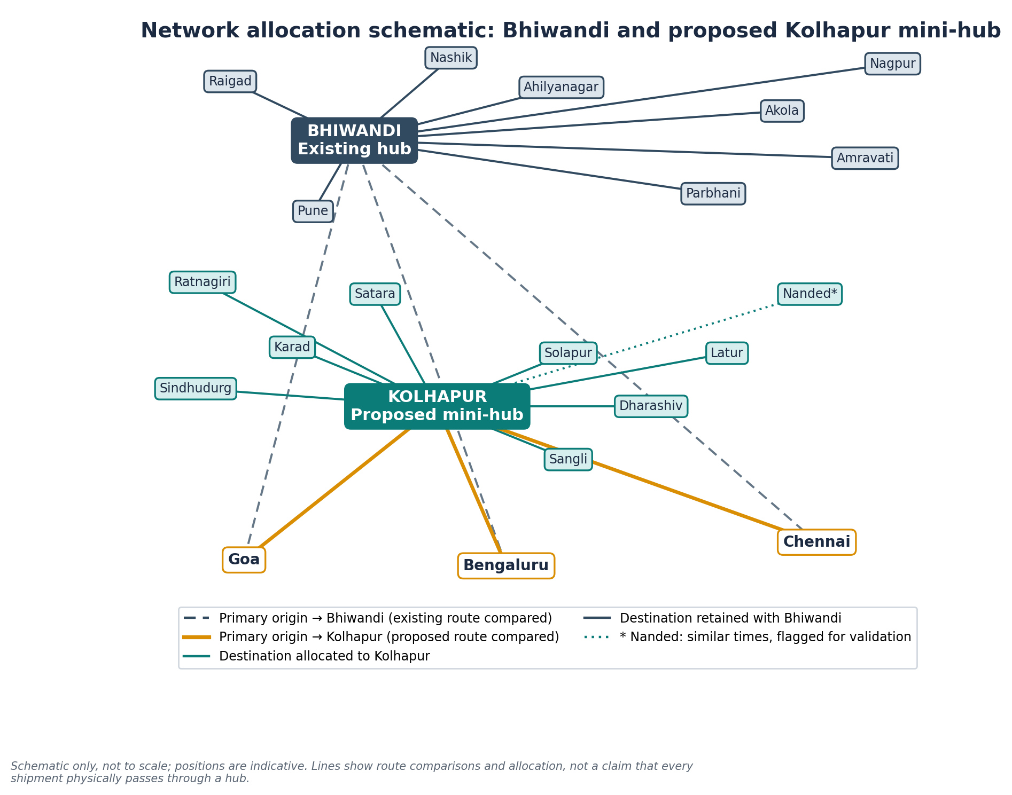
Schematic, not to scale. Lines show route comparisons and allocation, not a claim that every shipment passes through a hub. * Nanded requires further validation; Solapur has a preliminary comparison and needs final route and commercial validation.
Hub | Destinations
Kolhapur (proposed) | Sangli, Satara, Karad, Ratnagiri, Sindhudurg, Latur, Nanded*, Dharashiv, Solapur
Bhiwandi (existing) | Pune, Ahilyanagar, Parbhani, Amravati, Akola, Nagpur, Nashik, Raigad
The allocation is a working recommendation, not a mathematically optimised network. Not every destination has been fully validated.
Consideration | Cost implication
Shorter primary and secondary movements | Source of the modelled saving; depends on rates holding and on volumes bound for the Kolhapur catchment.
Cost of an additional hub | Fixed and semi-fixed costs that must be covered by the gross saving (break-even ₹2,60,560 in this model).
Load consolidation and vehicle utilisation | The model assumes full 20-machine loads. Part-loads raise cost per machine.
Handling and transfer costs | Extra transfers between hubs are not in the model and could offset savings.
Vendor availability | Rates assume vendors are available on Kolhapur lanes, including return loads.
Shipment density | Too little volume at Kolhapur leaves hub costs spread over few machines.
Service-level commitments | Cost savings are only valuable if delivery windows are met; see the transit-time report.
Capacity and complexity | A second hub adds coordination and allocation rules to manage.
Whether the extra hub is economically justified depends on net benefit after all incremental costs, which cannot be determined until those costs are measured.

9 Financial Risk Register
Ratings are preliminary qualitative assessments, not measured risk scores. Evidence reflects what is currently available.
Risk | Financial / operational impact | Evidence available | Mitigation | Owner | Rating (prelim.)
Incorrect or outdated route assumptions | Savings over- or understated | Distances differ from transit-time report | Re-validate all lanes and rates | Network planning | High
Freight-rate changes | Saving erodes if Kolhapur rates rise | Rates supplied as point values | Refresh quotations; test rate sensitivity | Procurement | Medium
Low shipment volume | Hub cost not covered | None: volumes unavailable | Obtain volumes by lane | Network planning / finance | High
Underutilised vehicles | Cost per machine above model | Model assumes 20 per load | Track utilisation by trip | Transport operations | Medium
Higher-than-expected hub expenses | Net benefit shrinks or turns negative | None: costs not measured | Cost the hub bottom-up; use break-even | Finance / hub operations | High
Additional handling and transfer costs | Not captured in model | None | Measure transfer cost per machine | Hub operations | Medium
Vendor availability | Delays or higher rates | None | Pre-qualify vendors | Procurement | Medium
Service-level deterioration | Customer impact; penalties | Transit-time data are map estimates only | Monitor on-time %; keep Bhiwandi fallback | Customer service | High
Unverified Chennai cost inputs | Chennai saving may be wrong | Working figures; Kolhapur cost equals Bengaluru Bhiwandi cost | Check original quotation | Finance / head office | High
Mismatch of assumed vs actual volume | Total saving misstated | 80 machines/route is an assumption | Rebase on actual volumes | Finance | High
Ratings are qualitative and preliminary, not derived from V5 data.

10 Management Dashboard and KPIs
A monthly dashboard is recommended. KPIs in group A can be computed from the scenario model; group B needs actual finance, transport or hub records.

A. Calculable from the scenario model
KPI | Formula | Source | Frequency | Owner
Cost per machine | Total route cost ÷ machines | Model / finance | Monthly | Finance
Primary / secondary / last-mile cost | Component totals by route | Model / invoices | Monthly | Finance
Total logistics cost by route | Sum of components | Model / invoices | Monthly | Finance
Gross transportation-cost saving | Baseline cost − proposed cost | Model | Monthly | Finance
Break-even hub cost | Equals gross saving | Model | Monthly | Finance

B. Require actual records
KPI | Formula | Source | Frequency | Owner
Cost per trip | Total transport cost ÷ completed trips | Vendor invoices, trip logs | Monthly | Transport ops
Cost per kilometre | Transport cost ÷ actual km | Invoices, GPS/trip logs | Monthly | Transport ops
Incremental hub operating expenses | Actual Kolhapur facility, labour, handling, admin cost | Finance ledgers | Monthly | Finance
Net transportation-cost benefit | Gross saving − incremental hub costs | Finance | Monthly | Finance
Vehicle utilisation | Load carried ÷ capacity × 100 | Loading records | Weekly | Transport ops
Cost per tonne | Cost ÷ actual tonnes (if weight data exist) | Weighbridge/loading records | Monthly | Finance
Actual transit time | Arrival − dispatch timestamp | TMS / POD | Weekly | Transport ops
On-time delivery % | On-time ÷ total deliveries × 100 | TMS / customer SLA | Weekly | Customer service
Hub turnaround time | Vehicle exit − entry timestamp | Gate logs | Weekly | Hub operations

11 Implementation Roadmap
Recommended sequence only. No dates, budgets or approvals are proposed, and no phase is claimed to have occurred.
Phase | Activity | Output
1 Commercial validation | Confirm primary freight quotations, secondary rates, last-mile costs, vehicle capacity and Chennai inputs | Validated rate sheet
2 Baseline establishment | Collect actual shipment volumes, trip frequencies, invoices and costs by route | Verified cost baseline
3 Hub-cost assessment | Quantify incremental Kolhapur facility, staffing, handling and administrative expenses | Measured hub cost
4 Pilot | Compare actual performance on selected routes over consistent periods | Pilot results
5 Financial validation | Compare actual baseline cost with actual post-change total cost, including hub expenses | Verified net benefit
6 Scale-up decision | Expand, modify or discontinue based on validated net benefit and service performance | Management decision

12 Data Limitations
- Quantities (80 machines per route; 240 machines; 12 loads) are modelling assumptions, not actual volumes.
- Rates and costs are supplied; none were independently verified.
- Chennai primary costs are working figures pending confirmation; no distance or rate was derived.
- Incremental Kolhapur hub costs are unavailable.
- Secondary cost is a flat per-machine figure on all routes; destination-level rates are not available.
- Cost distances differ from the transit-time report and were not reconciled.
- No revenue data exist, so net benefit cannot be expressed as a margin.
- The model does not include the Bhiwandi-to-Kolhapur transfer leg or any cross-hub movement.

13 Final Recommendation
Financially disciplined conclusion
The supplied model indicates potential modelled gross transportation-cost savings of ₹2,60,560, or 14.78%, across three illustrative route comparisons using 80 machines per route.
The result depends on the supplied rates, machine quantities and route costs. The Chennai primary cost inputs require confirmation, and incremental Kolhapur hub costs are not available. A 5–6% net benefit is a planning hypothesis only: it would require incremental hub costs of about ₹1,54,816 to ₹1,72,440 for the modelled volume, and is not an actual company result.
Management should validate the commercial inputs, measure the additional hub cost, and compare actual post-implementation performance with the baseline before making the decision.

Appendix A Financial Assumptions
Item | Value | Classification
Machines per route | 80 | Assumption
Machines per vehicle | 20 | Source input
Goa Bhiwandi: 600 km × ₹40 | ₹24,000/vehicle | Source input
Goa Kolhapur: 250 km × ₹44 | ₹11,000/vehicle | Source input
Bengaluru Bhiwandi: 1,000 km × ₹38 | ₹38,000/vehicle | Source input
Bengaluru Kolhapur: 630 km × ₹42 | ₹26,460/vehicle | Source input
Chennai Bhiwandi primary | ₹48,600/vehicle | Source input – unconfirmed
Chennai Kolhapur primary | ₹38,000/vehicle | Source input – unconfirmed
Secondary per machine | ₹3,000 Bhiwandi / ₹2,500 Kolhapur | Source input
Last-mile per machine | ₹2,500 both | Source input
Planning hypothesis | 5–6% net benefit | Scenario assumption
Incremental hub costs | Not available | Illustrative sensitivity values only

Appendix B Formulas and Audit Trail
Item | Calculation
Primary cost per vehicle | Distance × rate (Goa, Bengaluru); supplied (Chennai)
Primary per machine | Per vehicle ÷ 20
Total per machine | Primary + secondary + last-mile
Route cost | Total per machine × 80
Gross saving | Bhiwandi cost − Kolhapur cost
Reduction % | Gross saving ÷ Bhiwandi cost × 100
Total baseline | 5,36,000 + 5,92,000 + 6,34,400 = 17,62,400
Total proposed | 4,44,000 + 5,05,840 + 5,52,000 = 15,01,840
Combined saving | 17,62,400 − 15,01,840 = 2,60,560
Combined reduction | 2,60,560 ÷ 17,62,400 = 14.784% → 14.78%
Scenario A (5%) | 17,62,400 × 5% = 88,120; hub cost = 2,60,560 − 88,120 = 1,72,440
Scenario B (6%) | 17,62,400 × 6% = 1,05,744; hub cost = 2,60,560 − 1,05,744 = 1,54,816
All calculations are reproduced with live formulas in V5_Transportation_Cost_Model.xlsx; model-minus-supplied differences are ₹0 for every rupee total.

Appendix C Data Notes and Reconciliation
Item | Supplied | Recalculated / note
Combined reduction | 14.79% | 14.78% (14.784%); rounding correction
All rupee totals | As supplied | Match exactly
Goa–Kolhapur cost distance | 250 km | 223 km in transit-time report (digits unclear there); kept as supplied
Bengaluru cost distances | 1,000 / 630 km | 1,002 / 631 km in transit-time report; kept as supplied
Chennai primary costs | ₹48,600 / ₹38,000 | Unconfirmed; Kolhapur figure equals Bengaluru Bhiwandi vehicle cost, so verify
Per-machine average saving | — | ₹1,085.67, shown as ₹1,086

